Chapter Supplies 2015-2016
Sigma Nu Tau Entrepreneurship Honor Society

Sigma Nu Tau Entrepreneurship Honor Society
Attention: Dr. Nancy J. Church
SUNY Plattsburgh
101 Broad Street
Plattsburgh, NY 12901
Telephone: 518-564-4169
Fax: 518-564-3183
Email: Nancy.Church@Plattsburgh.edu
Website: www.sigmanutau.org

Embroidered Sigma Nu Tau Tablecloth
Description: Rectangular Polyester Tablecloth. Washable. 60 x 102 inches
Color: Hunter Green
Price: $65.00

Embroidered Sigma Nu Tau Women’s Polo Shirt
Description: Women’s polo, slightly contoured for flattering fit, 4-button placket, 50% cotton polyester jersey, spot-shield stain-resistant treatment, welt-knit collar, double-needle-stitched bottom hem, tag-less label, embroidered with the Sigma Nu Tau logo.
Color: Hunter Green
Size: S, M, L, XL
Price: $30.00 (May take up to 4 weeks)

Embroidered Sigma Nu Tau Men’s Polo Shirt
Description: Men’s polo with seamless body, 2-button placket, 50% cotton polyester jersey, spot-shield stain-resistant treatment, welt-knit collar, double-needle-stitched bottom hem, tag-less label, embroidered with the Sigma Nu Tau logo.
Color: Hunter Green
Size: S, M, L, XL, 2XL, 3XL
Price: S-XL $30.00 / 2XL/3XL $34.00 (May take up to 4 weeks for production)

Sigma Nu Tau Honor Cord
Description: Gold and Hunter Green Intertwined Honor Cord for Graduation. Mixed Hunter Green & Gold tassels on each end.
Color: Hunter Green/Gold
Size: 71 inches long
Price: $10.00

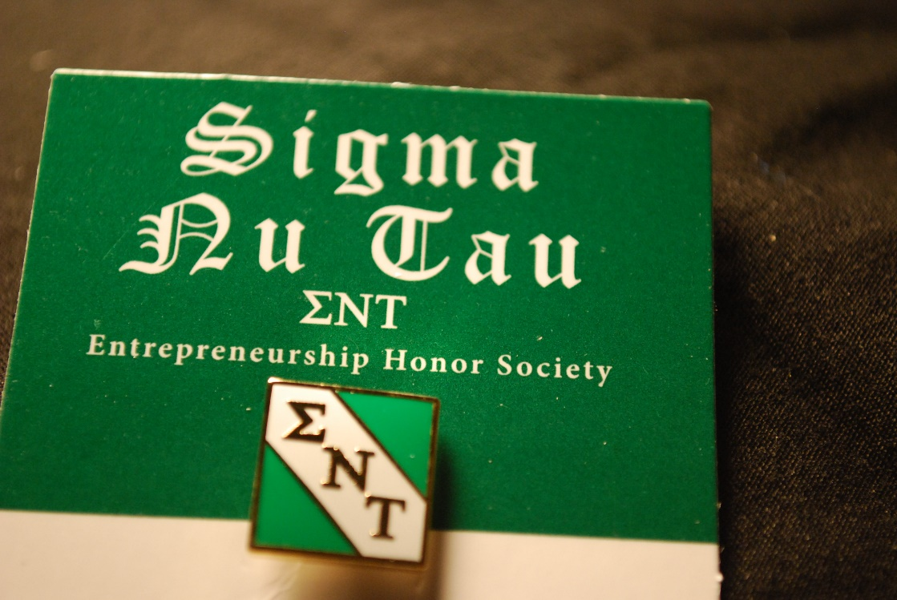

Sigma Nu Tau Lapel Pin
Description: Square lapel pin displaying the letters Sigma Nu Tau. Measures ½” x ½”.
Color: Hunter Green/Gold/White
Price: $6.00

Sigma Nu Tau Crystal Paperweight
Description: Elegant, oval, full-leaded crystal paperweight with Sigma Nu Tau logo comes in a beautiful, lined gift box
Color: Crystal

Size: 3/4 " x 4 " x 2-7/8"
Price: $20.00

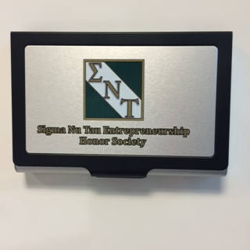

Sigma Nu Tau Business Card Case
Description: Black and brushed silver business card case embossed with Sigma Nu Tau logo. Boxed.
Color: Brushed Silver and Black
Size: 2-1/2” x 3-3/4”
Price: $8.00

